Lab 3 Resistor Specifications
Pre-Lab Questions
Review the sample datasheet shown in Figure 1.0 and identify the following specifications:
- Nominal resistance: 1k ohm
- Resistance tolerance: +-5%
- Minimum allowable resistance: 950ohm
- Maximum allowable resistance 1050ohm
- Maximum power rating: .5W
- Operating temperature range: -55C to 155C
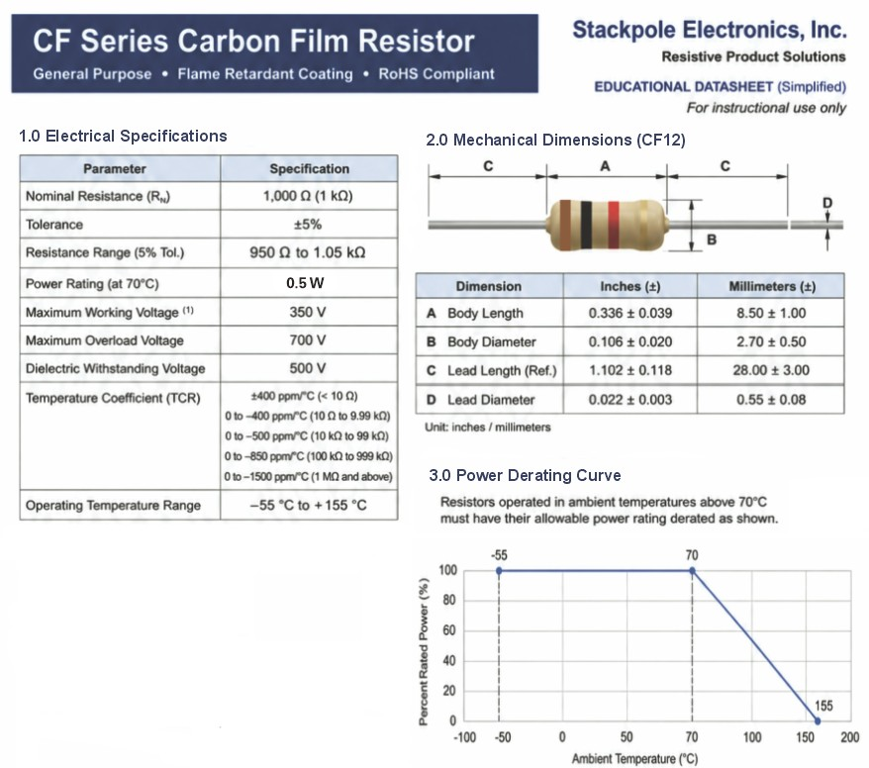
Figure 1.0 Simplified datasheet for a 1 kΩ, ±5%, 0.5 W carbon film resistor.
- What is the minimum allowable resistance for this 1 kΩ resistor with 5% tolerance?
R(min) = 1000-(0.05)(1000) so we get R(min) as 950 ohms .95k ohm

- What is the maximum allowable resistance for this 1 kΩ resistor with 5% tolerance?
R(max) = 1000 + (0.05)(1000) which gives us 1050 ohm 1.05k ohm

- What is the minimum allowable resistance for a 1 kΩ resistor with 1% tolerance?
R(min) = 1000-(.01)(1000) which gives 990 ohm or .99k ohm

- What is the maximum allowable resistance for a 1 kΩ resistor with 1% tolerance?
R(max) = 1000 + (.01)(1000) which give 1010ohm or 1.01k ohm

- A 1 kΩ resistor has a specified tolerance of ±1%. Its measured resistance is 1024 Ω. Does it meet the specification? Explain your answer.
no because 1% is 10ohms 24 ohms is 2.4% variation wince 2.4>1 its disqualified

- When measuring many 1 kΩ resistors with ±5% tolerance, would you predict that values are equally common throughout 950–1050 Ω, or more common near a central value? Describe your predicted distribution. Does the tolerance specification alone determine its shape? Explain.
more common around 1000 ohm and less common near 950 or 1050 ohm. it could be bell shaped. the tolerance just tells the range 950-1050 ohm it doesnt tell the shape

- From the power derating curve in Figure 1.0, what is the maximum ambient temperature at which this resistor may dissipate its full rated power of 0.5 W?
70C because it stays at 100% full power until 70C

- From the power derating curve in Figure 1.0, what is the maximum allowable power at an ambient temperature of 85°C?
(155-85)/(155-70) = 70/85 = .8235 then .8235(.5) = .412W or .41W

- If the power supply in the lab is limited to a maximum voltage of 30 V per channel (on channels 2 and 3), how can you configure the instrument to create a voltage of 45 V?
connect CH2 and CH3 in series 30V + 15V = 45V

- When measuring DC voltage with a DMM, is the meter connected in series or in parallel with the component being measured?
parallel
- When measuring resistance with a DMM, is the meter connected in series or in parallel with the component being measured?
parallel across the resistor
- When measuring resistance with a DMM, can the component be powered by an external source?
no because when checking resistance the power needs to be off

- If the voltage across a resistor doubles, how does the power dissipation change? Explain using an equation.
P = V^2/R if it doubles P = (2V)^2/R = 4P so the power quadruples

- What is the equivalent resistance of three 10 kΩ resistors connected in parallel?
R(eq) = 10000/3 = 3333.3 ohm or 3.33k ohm

- A DC Power Supply with 40 V output is applied to three 10 kΩ resistors connected in parallel, together do these dissipate approximately the same power as the single 3.3 kΩ resistor? Show your equations.
3 10k ohm in parallel R(eq) = 3333.3 ohm P = 40^2/3333.3 = .480W. for one 3.3k ohm P = 40^2/3300 = .485W so yes about the same

